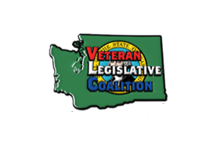***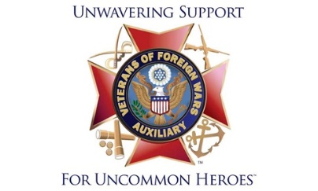******LEGISLATIVE*** Bulletin #1

**Elaine Taylor** [**taylor.90@comcast.net**](mailto:taylor.90@comcast.net)

Hi! My name is Elaine Taylor and I am excited to be your Legislative Chairman for the 2024-2025 election year! I had the opportunity to go to the Legislative session in Washington, D.C. last March and was so impressed by what our members do working with Congress, that I wanted to do and learn more.  As we delve into the Legislative Program, we will seize the opportunity to learn, grow, and make a lasting difference. United, our voices will be amplified, our actions will be purposeful, and our impact will be profound!

We are honored to have our Oak Harbor Post named after Murray Muzzall, who was killed overseas in the South Pacific in 1945. Murray is the uncle of our State Senator Ron Muzzall from the 10th Legislative District. Senator Ron Muzzall lives just a short 15-minute drive away!

IMPORTANCE OF LEGISLATIVE PROGRAM I consider the Legislative Program to be the root of all other VFW Auxiliary Programs and initiatives. After all, legislative rights are the reason the VFW and Auxiliary were formed.

The VFW Legislative Priority Goals, which are released annually, provide the framework for all VFW work on Capitol Hill in Washington, D.C (www. vfw.org/advocacy/national-legislative-service). All VFW Auxiliary Programs support and relate to the Priority Goals in one way or another. If we understand the *importance* of the Legislative Program, then our efforts to advocate for our veterans become that much more effective and our voices will be heard!

******IT ALL STARTS LOCALLY While it is imperative that we continue to monitor pending legislation in Congress, we must not forget that local government and laws also impact the quality of life for our veterans. The two go together and support for veterans’ rights begin locally. By establishing strong connections with our VFW and elected officials, we are demonstrating our commitment to the legislative process.

BE AN ADVOCATE ~ BE INFORMED ~ BE ENGAGED!